1) No option to add day to multiple dates

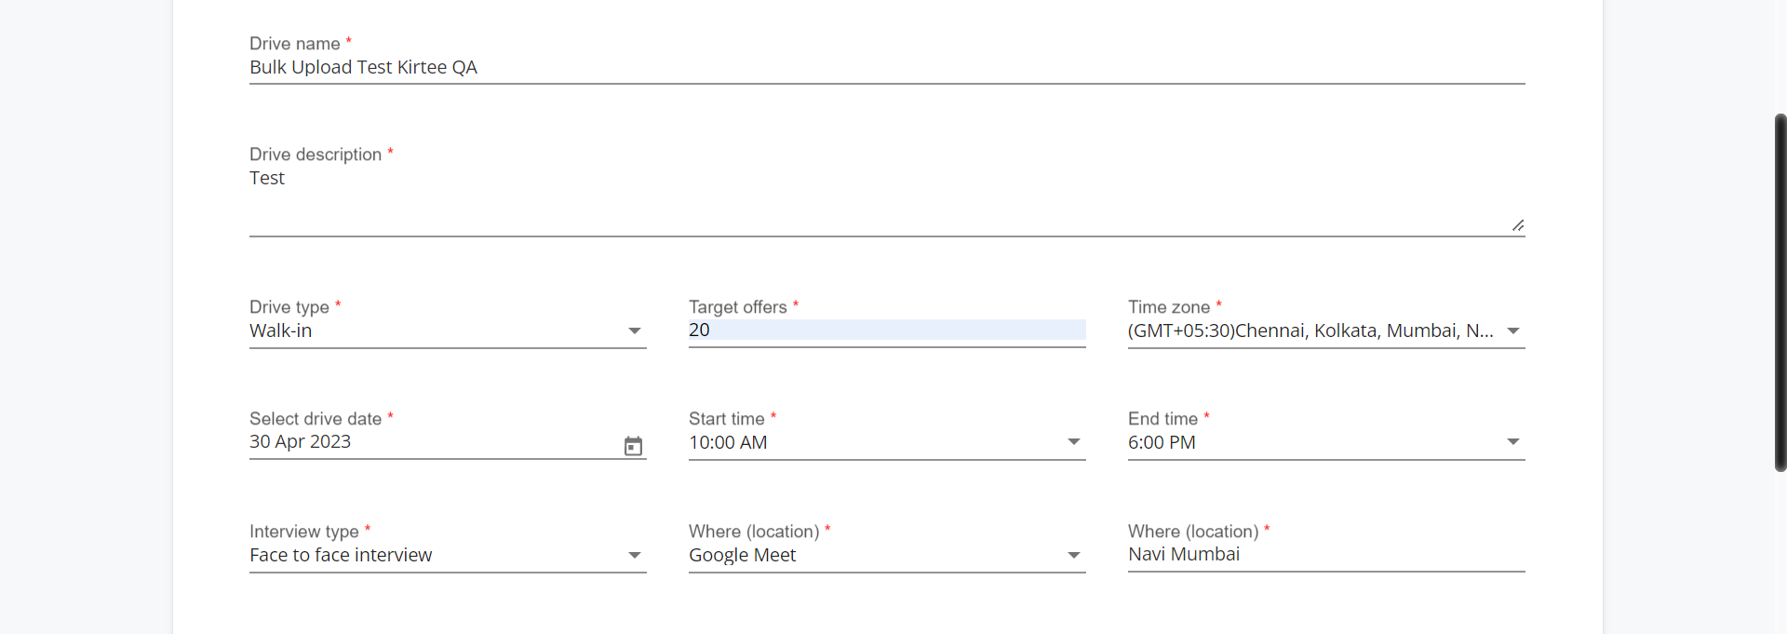

2) Start time accepts past time in Fill Drive Details page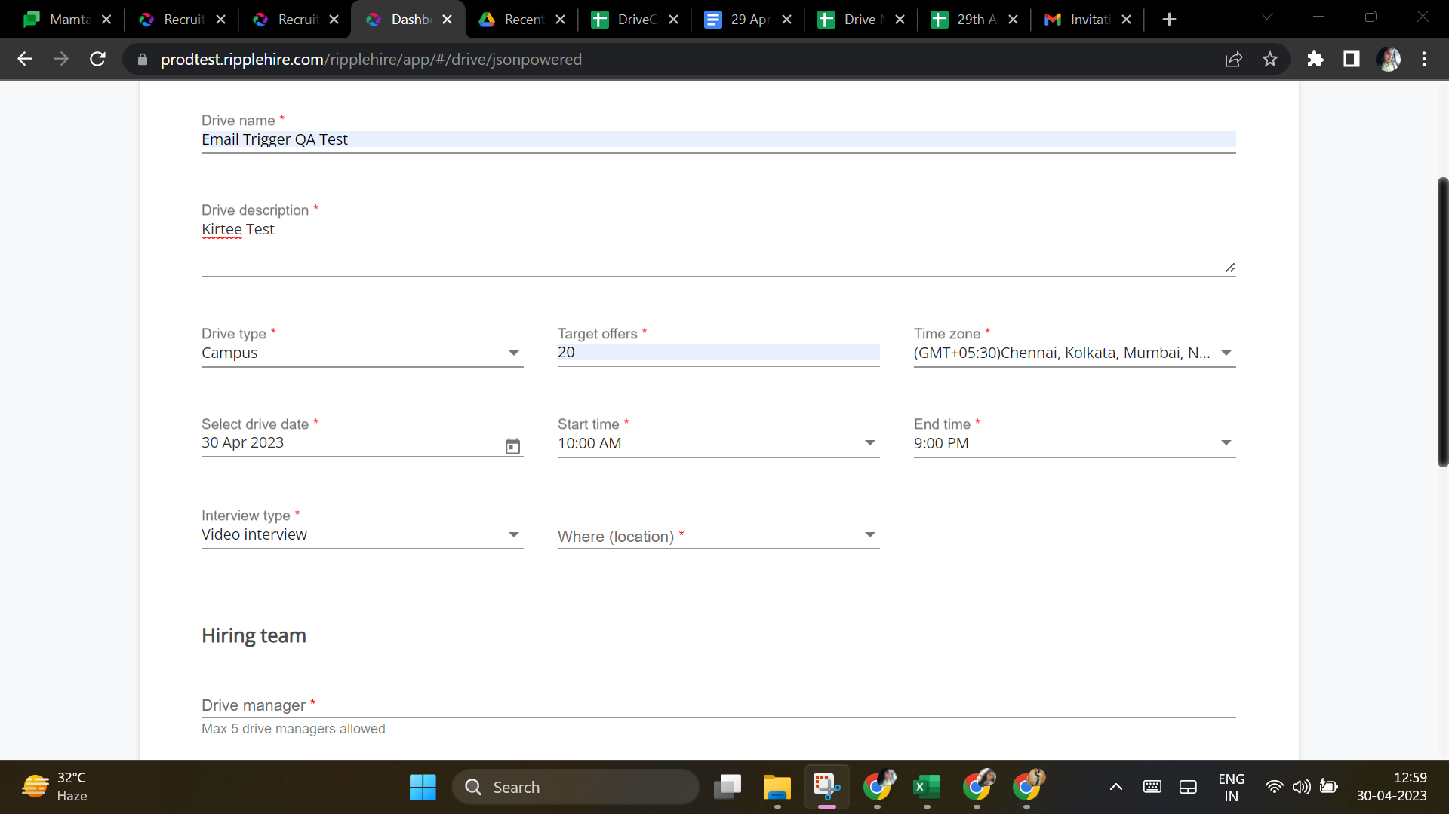

3) → Excel file is not excepted with 10 candidates in upload section

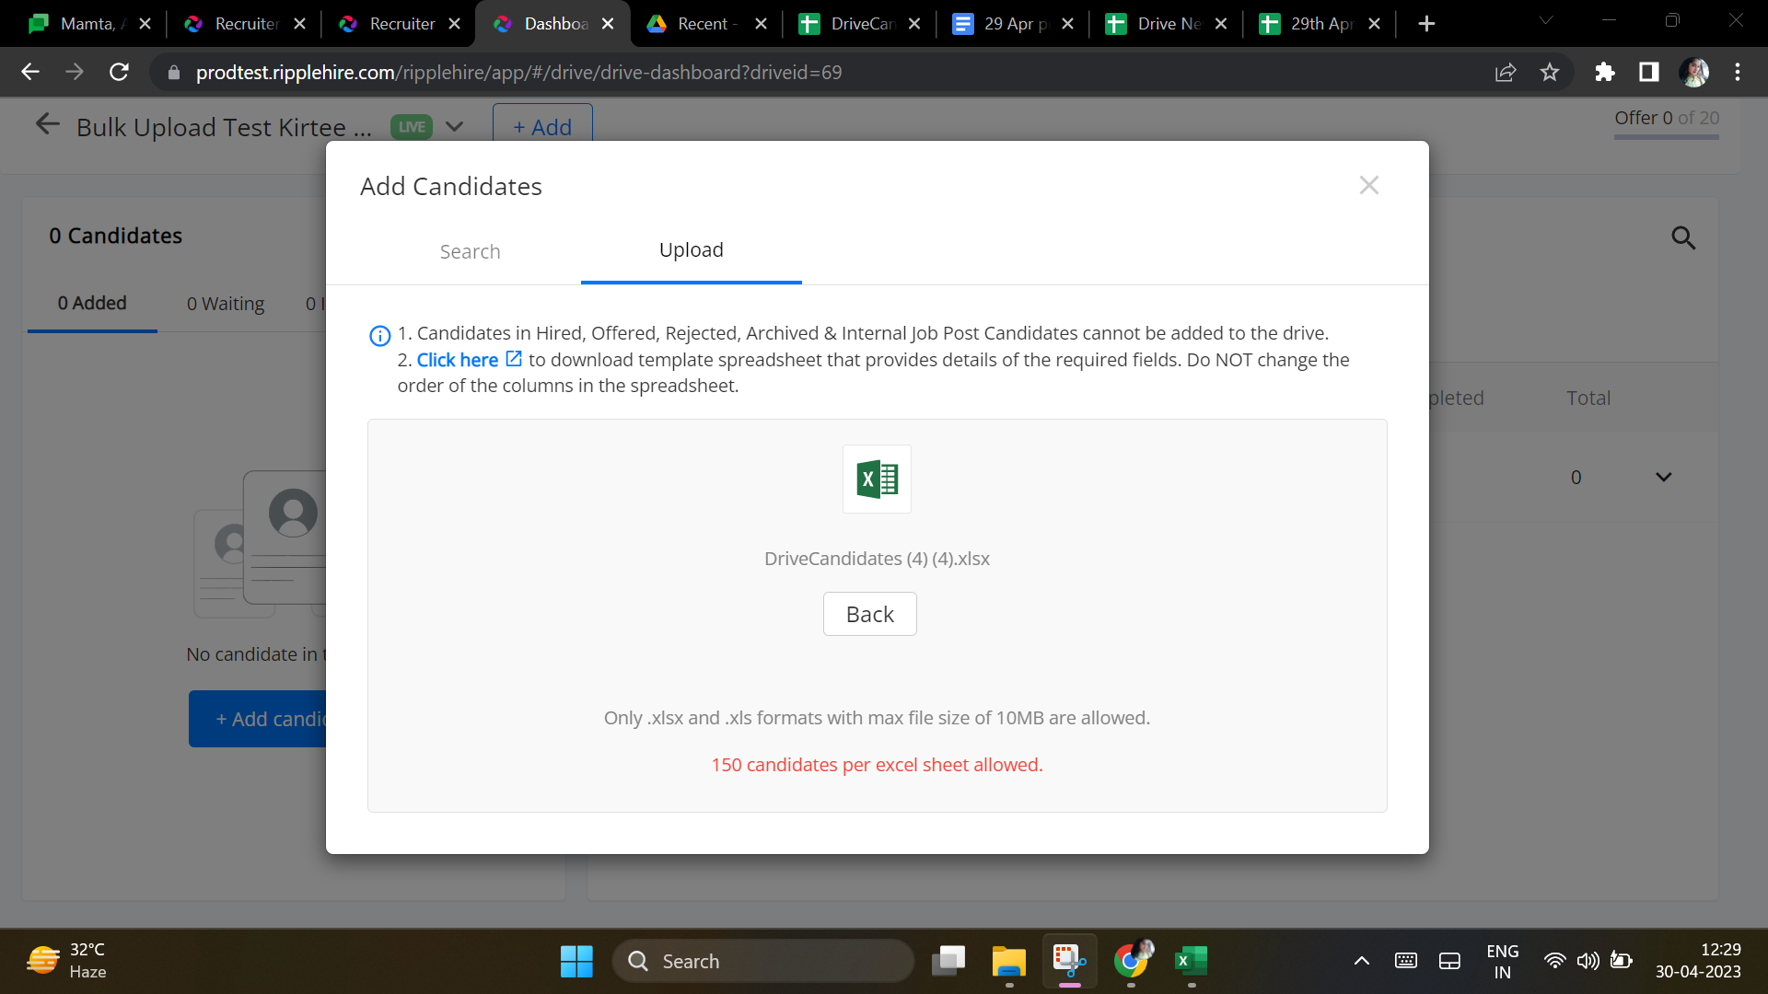

4) Edit drive link within drive :- Where location does not have Others option in edit details of face to face drive